BIM Collaboration Format Reader C:\Users\Jinsol.Kim\Desktop\comment (1 .png)\commen.png

*(Updated 2013-02-08 by Jinsol Kim)*

|  |
| --- |
| **What is BCF?**  BIM Collaboration Format (BCF) is an open standard to enable workflow communication between different BIM software like Tekla and Solibri. The BCF is built on XML schema that will contain entries of the information of issues and comments found in the BIM model. Sharing data with BCF file will give BIM coordinators benefits of a reduction in the data transfer with much lighter file size implementing improved workflow.  *See details in buildingSMART-tech*  <http://www.buildingsmart-tech.org/specifications/bcf-releases/bcf-intro>  **BCF Reader** was developed to improve the interoperability between Solibri Model Checker and Revit for commenting on issues generated from Soibri.  By allowing Revit to take control of the Solibri comment data, users can directly modify Revit model elements related to Solibri issues. |
|  |

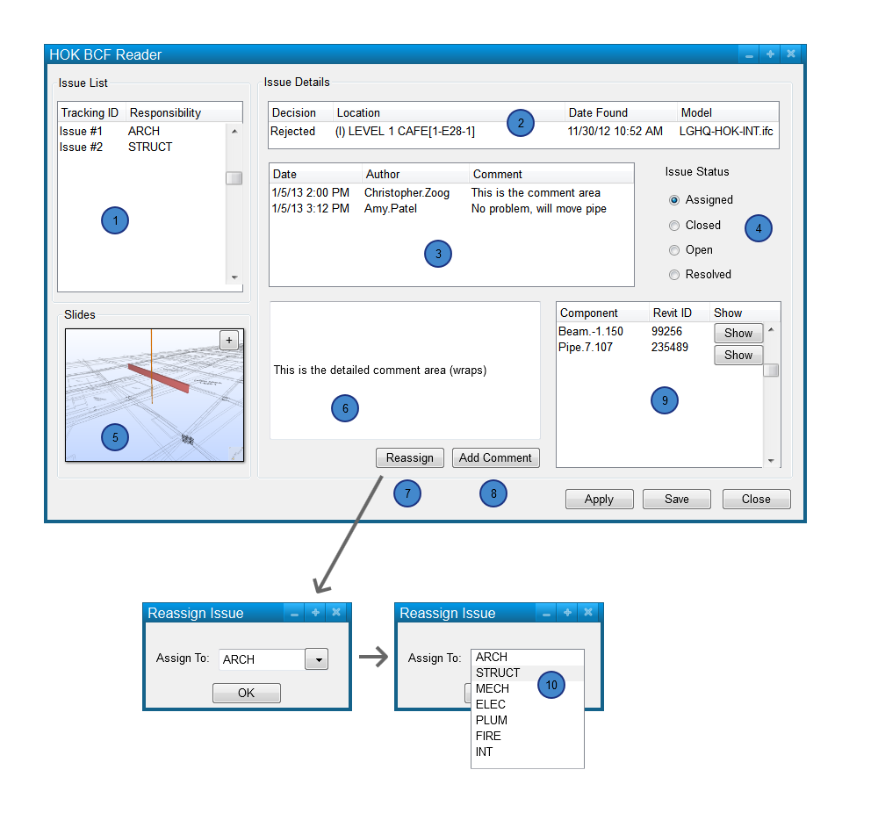

HOK BCF Reader GUI

1. Issue List:  Tracking ID and Responsibility comes from Solibri.  This table is non-editable, each row is an issue, selecting on a row updates the Issue Details, and the Slide included with that issue.
2. Issue Detail:  Decision refers to the checking decision made in Solibri, Location and Date Found come from Solibri.  Model refers to the IFC model to which the principal objects reside.  I think there can be two models on this list.  None of the fields are editable.
3. Comment List: Date stamp refers to when the comment was created in this or other applications.  Author is derived from the app in which the comment was made, in the case of Revit we can use the Revit user name.  I will investigate whether we can standardize this in Solibri.  This table is non-editable, selecting on a row updated the detailed comment area.
4. Issue status: can be changed here.
5. Slides: come from Solibri, multiple slide images would be nice, cycling through them like in Solibri. Hitting the plus sign opens the full size image.
6. Comment Detail area:  expanded area for multi-line comments
7. Reassign:  allows issue to be assign to somebody else, not sure if BCF is capable of this.
8. Add Comment: brings up text field, allows user to add a new comment.
9. Related Components:  Lists the component name from Solibri, the Revit ID, and the show button takes you to the element.
10. The responsible party list should come from Solibri, new values are possible.

Instructions

* + - 1. Creating BCF
      2. Reading BCF
      3. Edit BCF

-Issue

-Comment

-Show/Create 3Dview

-Write to shared parameters

* + - 1. Re-open BCF

Limitation: clashing while running

Responsible Party